

***Site for a Cinema***

***Manual***

Content

Introduction 3

How to access the site? 3

Authentication and Roles 3

User login 4

Dashboard 4

Adding, Updating, Deleting movie 5

Seances 7

Creating/Updating user accounts 8

Buying tickets 10

Checking tickets 13

## Introduction

This site is designed for a cinema.

It includes the following features:

* Adding user accounts for the cinema staff
* Adding movies with their seances
* Online tickets sell (downloading bought tickets as a pdf file)
* The Dashboard page which shows all the payments and information about income for different periods
* Site has two types of user roles: administrators and ticket controllers.
* The system authorizes user actions depending on their roles.
* The site is optimized for mobile and desktop users.

## How to access the site?

Before accessing the site please get in touch with me so I will be able to turn on my computer and share the site. (**WP/Viber/Telegram/Phone +374 96-74-21-06)**

The site is accessible through the sharing sail container.

To access the site, please visit <http://mypremiumcinema.laravel-sail.site:8080>

## Authentication and Roles

There are two types of available users. First one is a ticket controller user and the second one is the administrator. All the users registered in the system become a ticket controller user.

The administrator is a special type of a user, which is able to perform following actions

1. Register new users, promote/demote them to/from administrator, disable/enable users accounts

Administrator can perform actions with own account

1. Add, Edit and Delete movies, seances, cancel payments and tickets

The ticket controller is able to perform the following actions

1. View dashboard, payment history, movies and seances
2. Process tickets which includes checking the ticket validity by scanning the QR code on a ticket and setting the ticket status as used, to prevent ticket multiple usages.

|  |
| --- |
| **🏳** **You can Log In as administrator by using the following credentials.**  **E-mail:** [guest@mail.ru](mailto:guest@mail.ru)  **Password:** guestguest |

## User login

To login visit the following page http://mypremiumcinema.laravel-sail.site:8080/login or you can Log In by click the appropriate link on the footer.

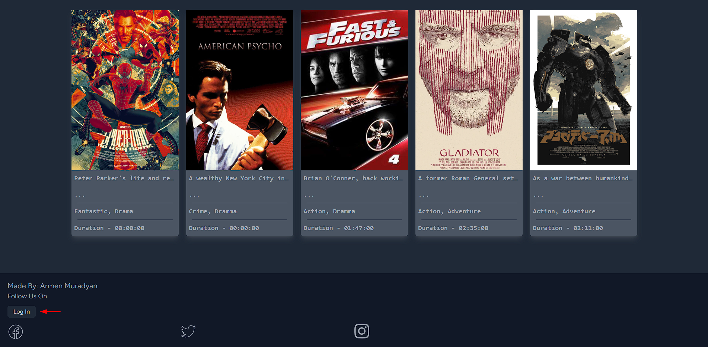

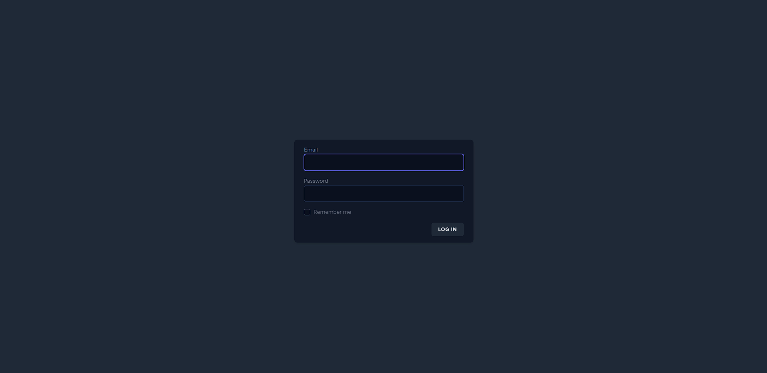

## Dashboard

Dashboard is the landing page after logging in. It contains information about Monthly/Weekly revenue and payment history. Administrator are able to cancel payments, during payment cancelation bought tickets will be canceled as well.

|  |
| --- |
| **🏳** **Only administrators are able to cancel payments.** |

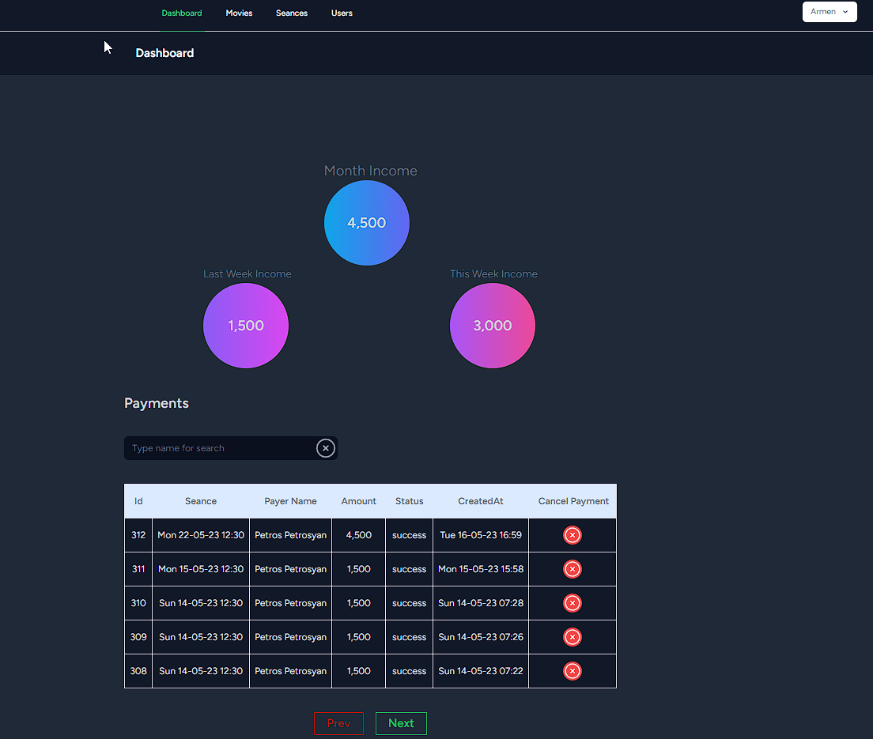

### Adding, Updating, Deleting movie

To add a new movie user must have the admin role. The administrator can navigate to the New Movie form by clicking, “Movies” on the menu bar, then on “Create New Movie” on a sidebar, as it is shown on the picture below.

|  |
| --- |
| **🏳** **Uploaded images must have size of 750 x 1125.** |

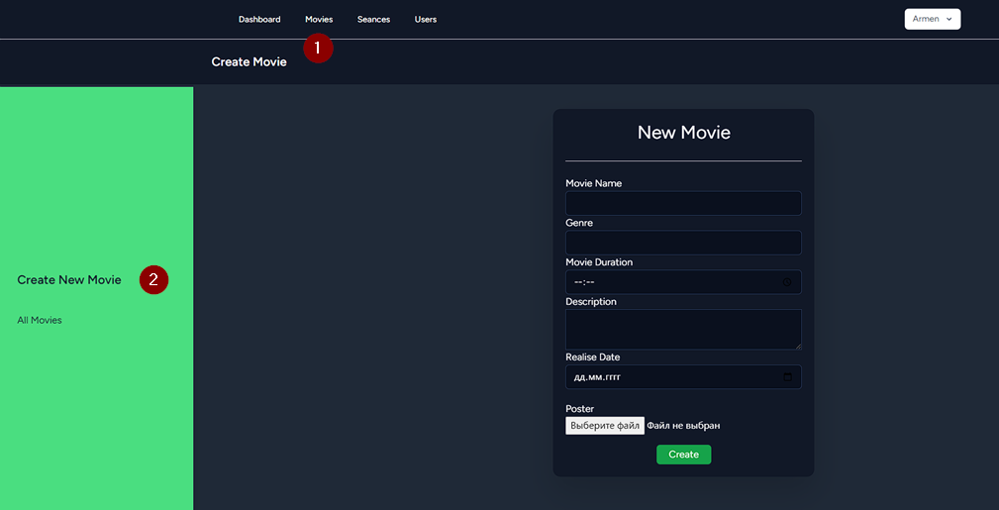

To view the list of available movies, go to /movies page. You can navigate to that page by clicking on the “All Movies” link on the sidebar.

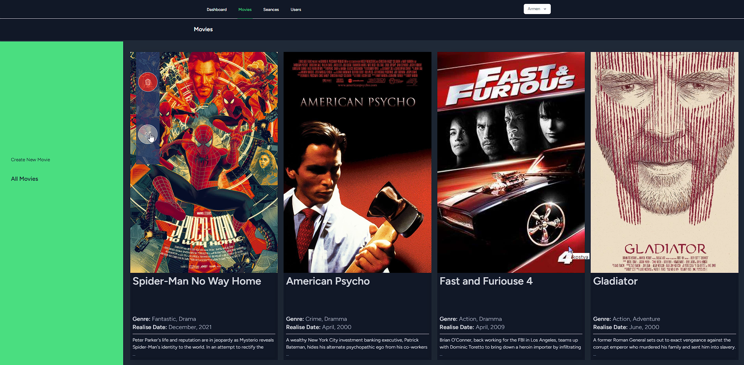

By hovering on a movie card, the delete and edit buttons will appear. Editing and deleting actions are performed by clicking those buttons.

Editing Movie

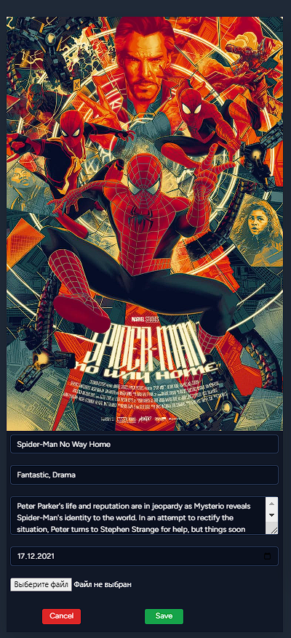

## Seances

List of seances are available for both roles of users by /seances path. You can navigate to the page by clicking “Seances” link on the menu bar.

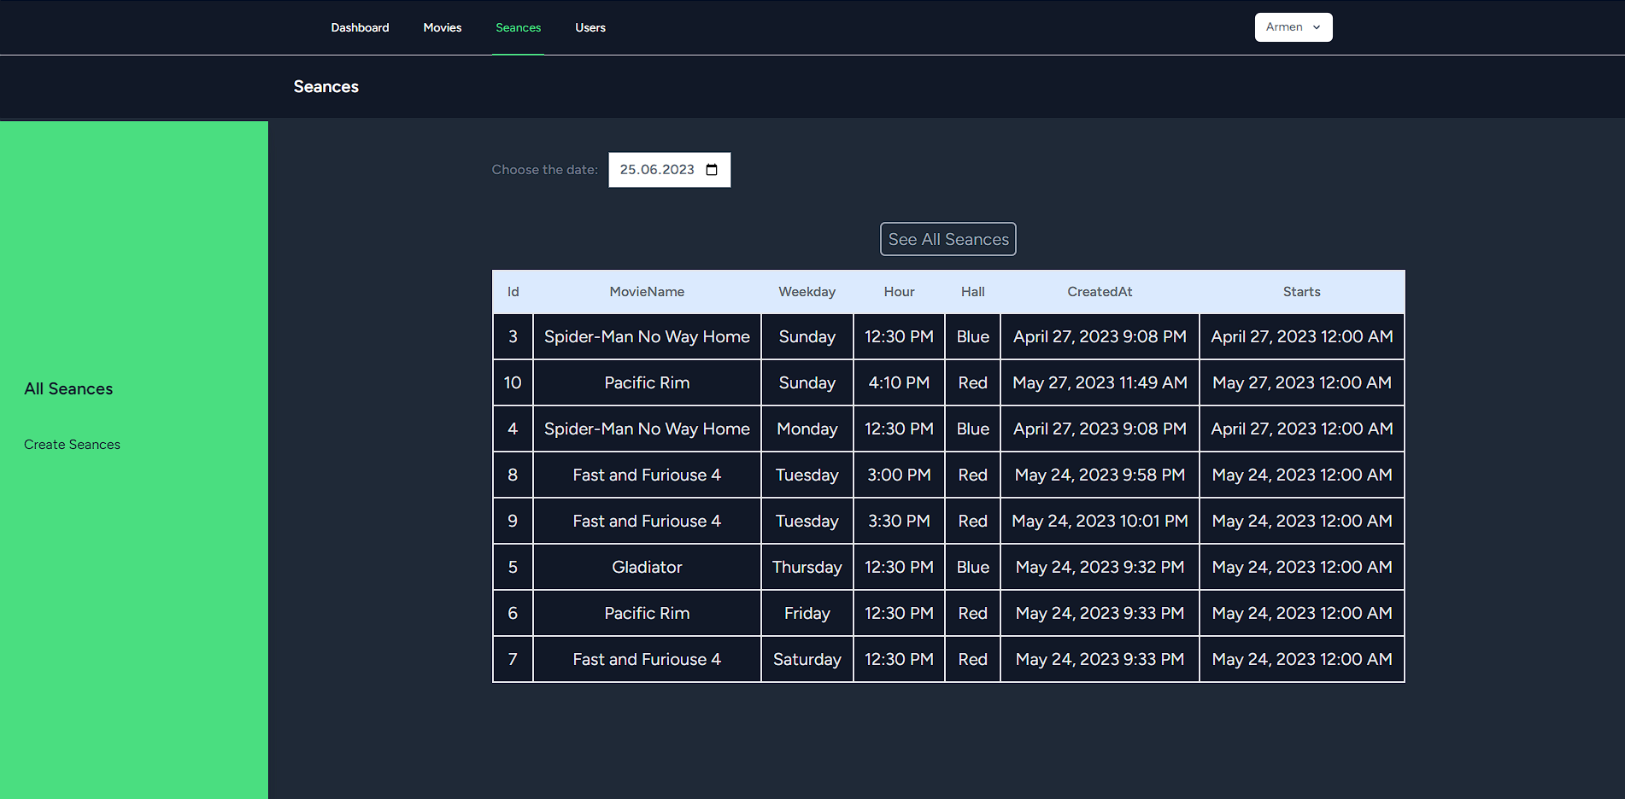

To create new seances, visit /seances/create by clicking on the “Seances” link on the menu bar.

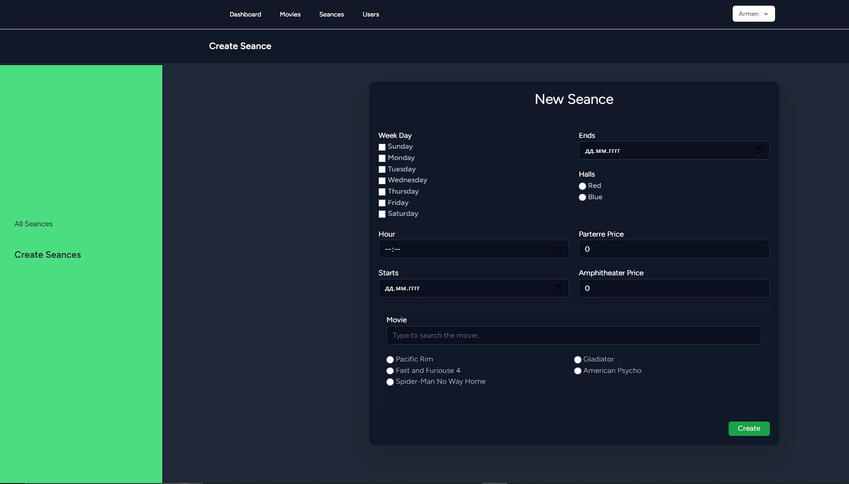

## Creating/Updating user accounts

Actions connected to creating and updating users can be performed only by administrators. To create a new user visit /users/create page.

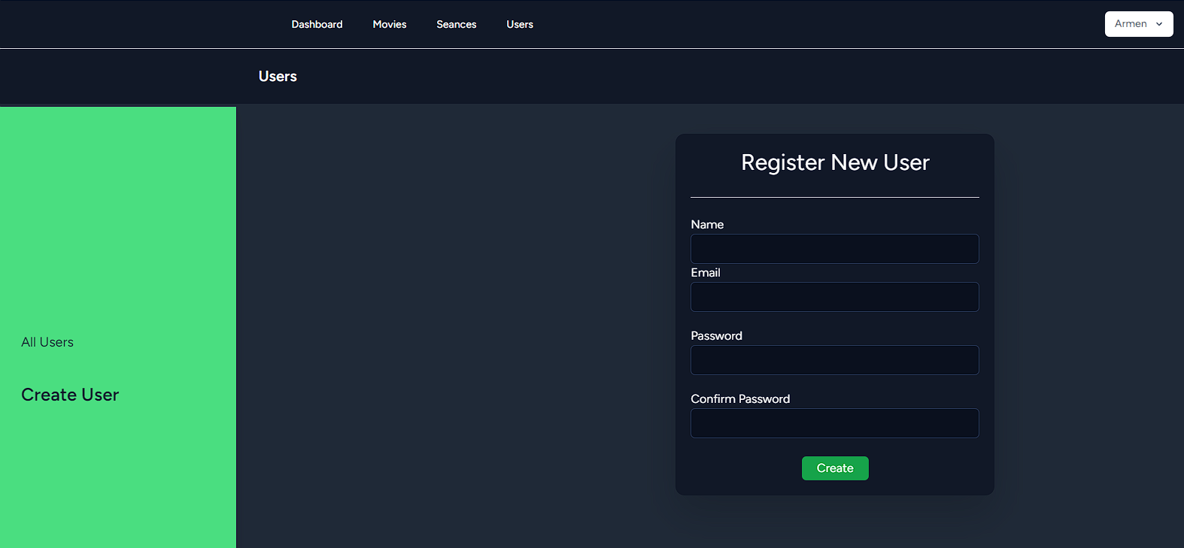

Newly created users are automatically assigned ‘Ticket Controller’ role.

To view the list of existing users, navigate to /users by clicking “Users” link on the menu bar.

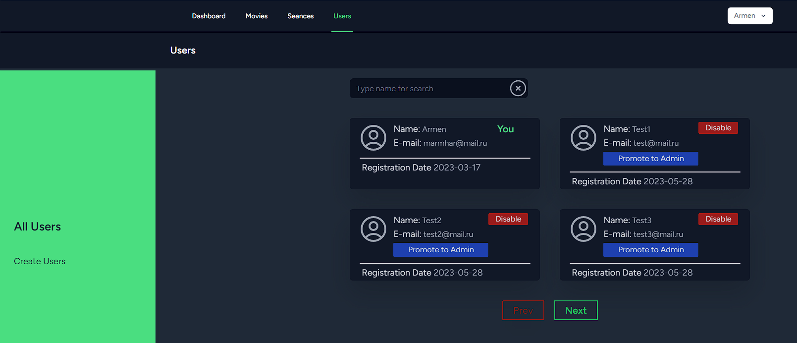

On this page administrators can promote/demote regular users to/from administrator and disable/enable their accounts.

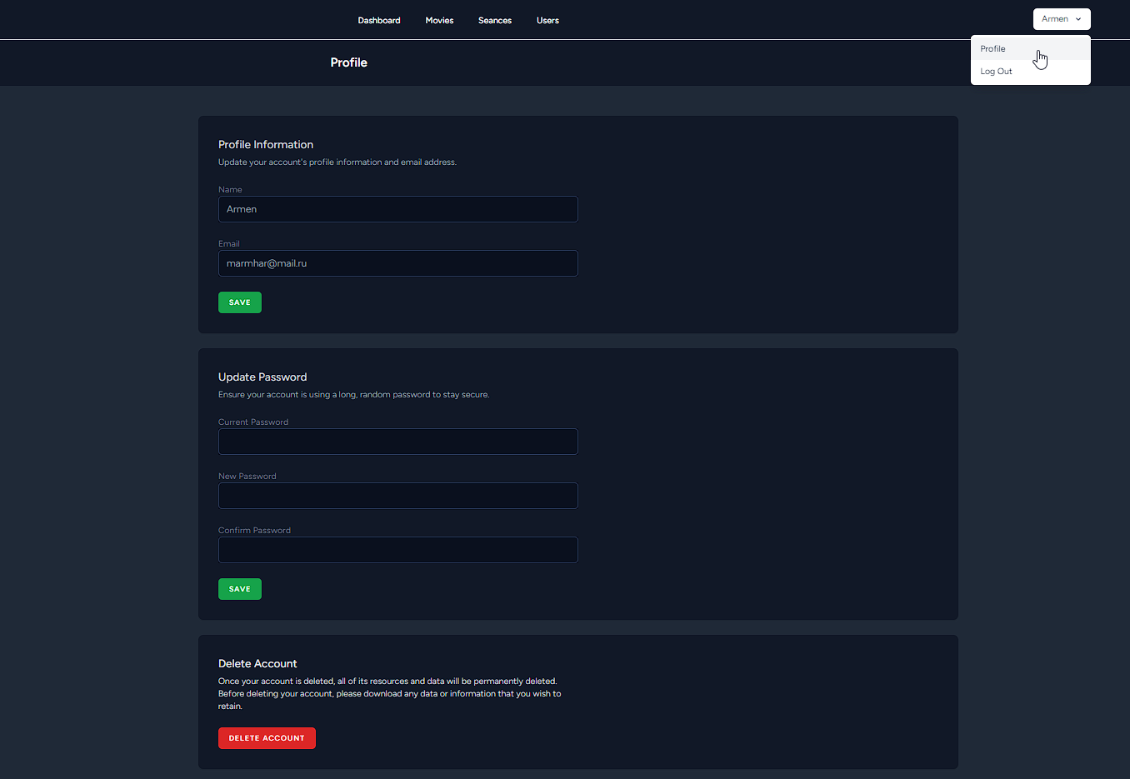

Every user has access to its own profile page by selecting “Profile” link in the dropdown menu as shown on the picture above. Using this page users can update their passwords, emails or delete their accounts.

## Buying tickets

Site visitors are able to buy tickets visiting the main page

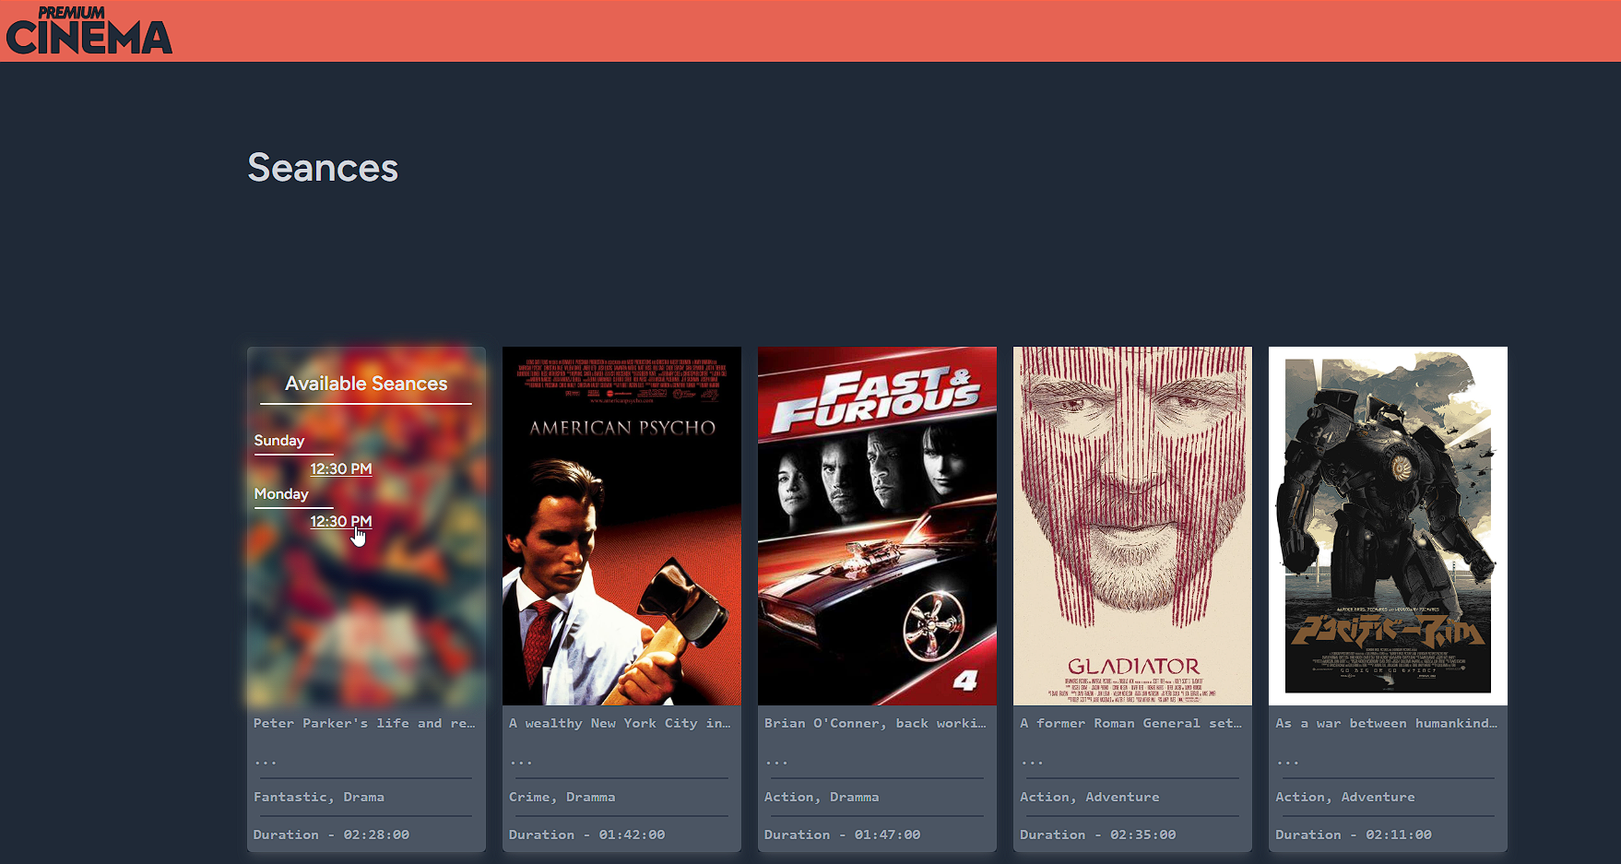

Available seances are shown on this page. By hovering on a movie card, visitors can see and choose a preferable seance from the list. Beside that they can read movie description by clicking on the ellipsis ‘**…**’

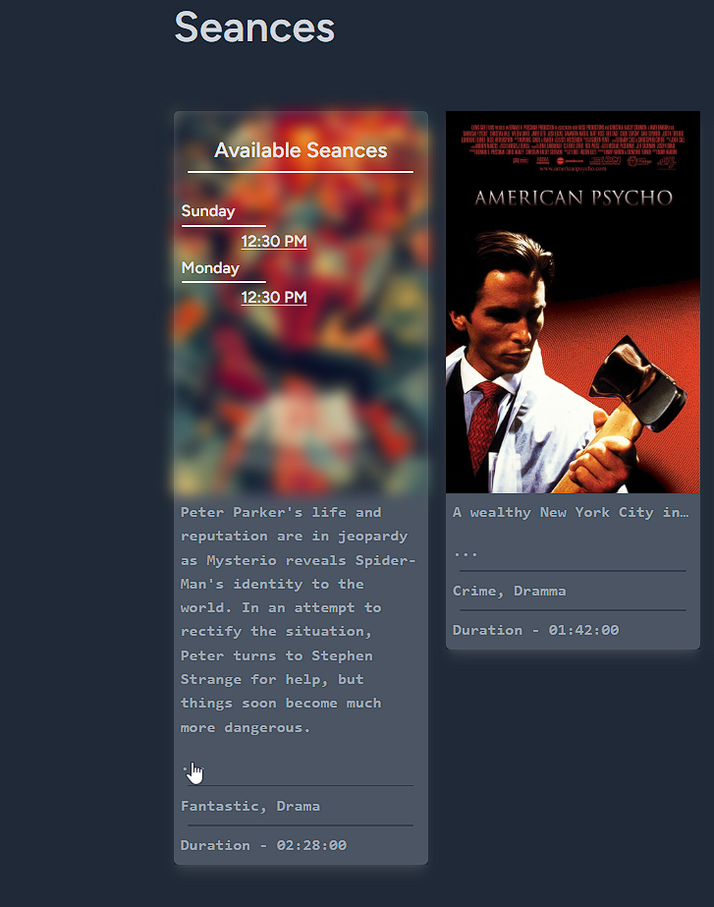

After selecting the seance, the page will be scrolled down to the hall view where the visitor can choose available seats. The seats that are already sold by other visitors will have gray color. Visitors can choose seats by clicking on them, the selected seats will color green and will be added in the list below. It is possible to undo the seat selection by clicking on it again or removing it from the list below by clicking on the cross button.

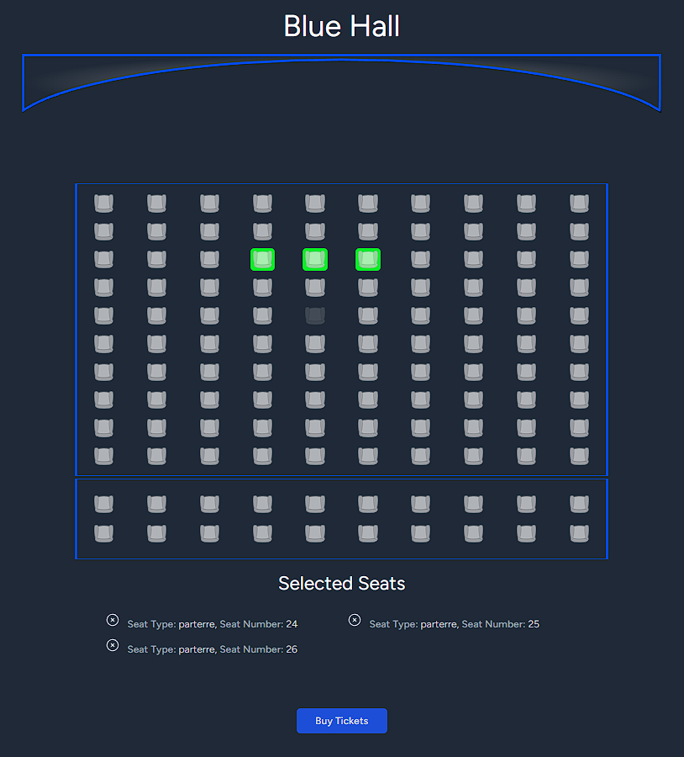

After selecting seats and clicking ‘Buy Tickets’ button, the page will be scrolled to the payment section.

Fill all the required field and press the ‘Confirm’ button.

The card number must match the following requirements:

* + - 1. Card number should consist of 16 digits.
      2. Card number must start with digit 4 or 5.

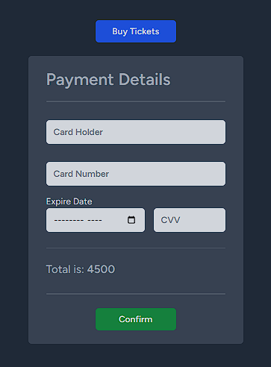

After completing the payment, the dialog shown on the picture below will appear. By clicking on ‘Download Ticket’ button it will start downloading tickets.

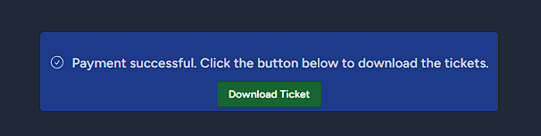

The tickets are contained in the downloaded pdf file and have the following look.

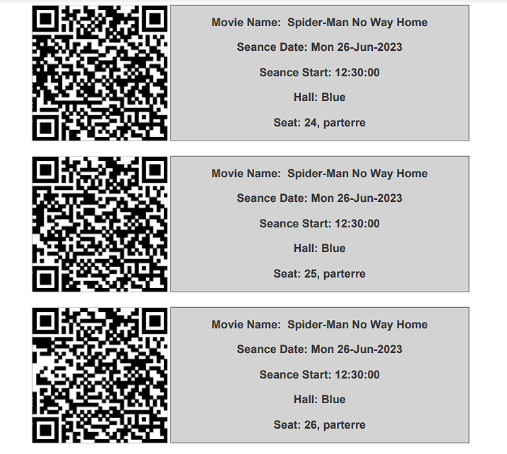

## Checking tickets

To check the ticket, ticket controller must scan the QR code on the ticket and follow the link encoded in the QR code. If the ticket is valid, the following page will be displayed.

If the ticket isn’t valid, the appropriate message will be displayed.

